Loretha Page
Amanda Jones
1301 IN03
11 March 2021
Formal Analysis and Critic of Caravaggio’s Painting
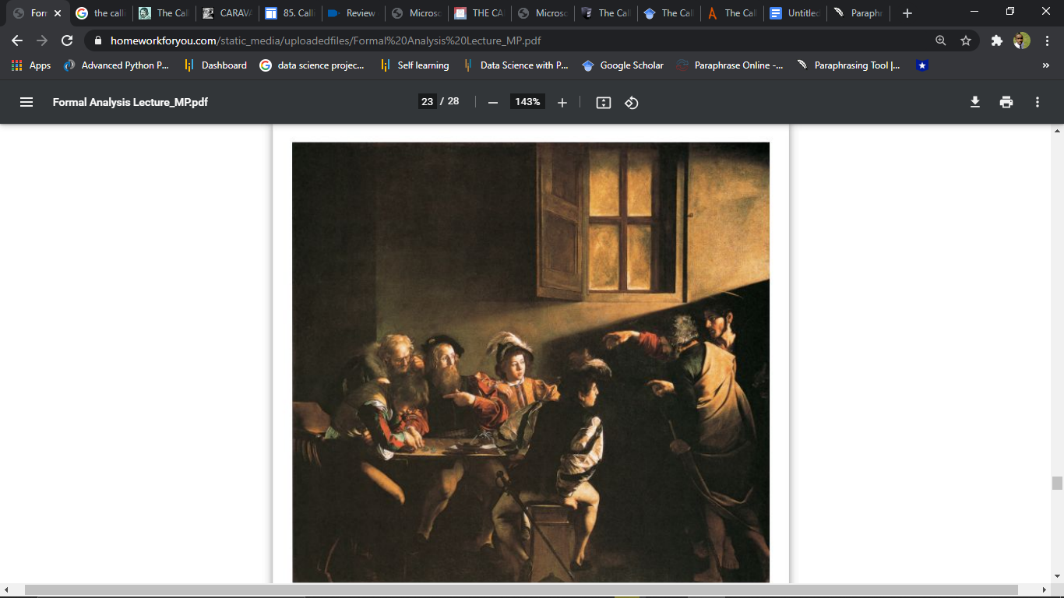
The calling of St Mathew Majestic's work is oil on a canvas, measuring (322 x 340 cm.) this painting is a famous and cherished masterpiece painting done by Caravaggio, one of the most admired and well known artists of the Seventeenth Century. Caravaggio’s masterpiece was painted between the years 1599 to 1600. This image exhibited, shows the scene when Jesus Christ motivated a tax collector named Mathew to follow him and influences him to become one of his believers. The painting was permitted as part of Cardinal Matthew Contarelli's will, which included investments and specific directions for the decoration of a cathedral inspired by Matthew's essence of life. The masterpiece was painted for the Contarelli Chapel in the cathedral in Rome, where it remains on exhibit to this very day. The paintings of Caravaggio showed a new Godly strength and testament. Caravaggio used several dark colors to make different shapes, instead of the fragile tints used by earlier artists, to create a more melodramatic interest that many have not seen in the seventeenth century. Caravaggio’s religious settings humanize and make commitment more approachable to the worshiper. In keeping with his simple, unmodified visuals, Caravaggio reuses from his earlier genre paintings and sets the stage to look like what seems to be a pub rather than a counting building or work station.
There are several elements of art and principles of design used in this art include; bold contrasting colors, use of organic line, soft texture, and the use of beaming light that acts as a headlight. The structure of this painting can be broken down into two depictions. One of the depictions is that the people form a vertical rectangle on the right side of the painting, while in the second depiction, a horizontal piece is formed on the left side of the painting. Light and shadow add drama to the painting. This drama is created by the contrast of the local people with the figures of Jesus and St. Peter who are seen wearing ancient clothing. The drama is further featured by the deep darkness in more than half of the painting, with light that is directly shining on Matthew. The poorly lit room and the conflicting light beam of the painting correspond to the typically dramatic paintings of the Baroque period. Caravaggio used chiaroscuro and tenebrism methods that were revolutionary at the time. Chiaroscuro is a term used to describe the distinction of dark and light in a painting, which creates spatial structure and volumetric shapes through subtle gradations in light and shadow intensity. Tenebrism refers to the use of powerful chiaroscuro and artificially lit areas in a painting to create an interesting distinction between light and dark (Strtak 343). Caravaggio uses a variety of many vibrant color palettes, some with bold contrasts of reds, gold, and greens, as well as various velvet and soft fur structures, to bring this artwork to life. Color and texture contrast supplement the figures and paintings' expressions and gestures. Caravaggio's colors create voluminous characters who seem to infringe on the viewer's space, particularly when the light shines on them (Strtak 343). The artwork reveals the aspect of continuity of the Baroque style as represented by men overlapped by shapes and other elements in the painting. The style distinguishes itself from Renaissance art, which has defined and divided planes with disassembling characteristics and figures. The continuity style is expressed by other values and features in the painting. For example, the characters in the artwork are simple, dramatic, and straightforward, which draws the viewer in and makes them want to be a part of the scene.
The image's vivid comparison and figures create an emotionally charged and emotionally genuine sensation. In the painting, Jesus looks more younger and noble. Mathew is seen pointing himself in disbelief, while one of the young men seems to be in some sort of distress. The use of realism in the calling of St Mathew makes it feel exciting and lively. This must have been very challenging for Caravaggio. Caravaggio does not show Jesus in an elevated position. He instead shows Jesus in a backroom of a tavern. This brings a sense of humility to the artwork.
Overall, the calling of St Mathew's painting effectively expresses the artist's message, which is the story of Levi, a tax collector who Jesus calls to become one of his followers. Levi was initially reluctant but eventually agreed to follow Jesus. In the painting, Jesus is seen pointing to Mathew, who in turn is pointing at himself in disbelief. Pointing at himself expresses the reluctance of Levi, who acts likes he is asking the question, “Why choose me, a tax collector, of all people.?”

WORKS CITED
Strtak, Jennifer. "Caravaggio and the Creation of Modernity." Renaissance and Reformation 40.3 (2017): 343-346.

